**Programing Questions:**

1. **Find out the number of days in between two  given dates ?**
2. **How to divide a number by 2 without using / operator?**
3. **How to multiply a number by 2 without using * operator?**
4. **How to swap two variables, by using pass by reference method ?**
5. **How to make a list immutable?**
6. **Write a sample code to reverse Singly Linked List by iterating through it only once.**
7. **Write a program to implement ArrayList and Linked list**
8. **Write a program for Insertion Sort in java.**
9. **Write a program to get distinct word list from the given file.**
10. **Find longest substring without repeating characters.**
11. **Write a program to remove duplicates from sorted array**
12. **Write a program to print fibonacci series.**
13. **Write a program to find out duplicate characters in a string**
14. **Write a program to create deadlock between two threads**
15. **Find out middle index where sum of both ends are equal**
16. **Write a program to find the given number is Armstrong number or not?**
    1. **Find out the number of days in between two given dates?**

**Code:**

**import** java.util.Scanner;

//Find out the number of days in between two given dates

**public** **class** Dayscount {

**static** **int** *daycount*;

**public** **static** **int** monthdays(**int** a,**int** b)

{

**if**(a==01 || a==03|| a==05 || a==07 || a==8 || a==10 || a==12)

{

*daycount* =31;

}

**else**{*daycount*=30;}

**if**(a==02){

**if**(b%4==0){*daycount*=29;}

**else**{*daycount*=28;}

}

**return** *daycount*;

}

**public** **static** **void** main(String[] args) {

Scanner s= **new** Scanner(System.***in***);

System.***out***.println("Enter start date: MMDDYY");

**int** MM1= s.nextInt();

**int** DD1= s.nextInt();

**int** YY1= s.nextInt();

System.***out***.println("Enter last date:MMDDYY");

**int** MM2= s.nextInt();

**int** DD2= s.nextInt();

**int** YY2= s.nextInt();

**if**((YY1==YY2)&&(MM1==MM2))//same month

{

**int** numberofDays= (DD2-DD1)-1;

System.***out***.println("Number of days in between dates " +MM1+"-"+DD1+"-"+YY1 +" & " +MM2+"-"+DD2+"-"+YY2 +" are: " +numberofDays);

}

**if**((YY1==YY2)&&(MM1!=MM2)){//same year but different month

**int** Mon_days1= *monthdays*(MM1,YY1)-DD1;

**int** sum=0;

**for**(**int** m=MM1+1;m<MM2;m++){

sum=sum+*monthdays*(m,YY1);

}

sum=sum+DD2+Mon_days1;

System.***out***.println("Total days between:" + MM1+"-"+DD1+"-"+YY1+ " & " + MM2+"-"+DD2+"-"+YY2+ " are:" +sum);

}

**if**(YY1!=YY2){

**int** Mon_days1= *monthdays*(MM1,YY1)-DD1;

**int** sum=0,sum1=0,sum2=0;

**for**(**int** m1=MM1+1;m1<=12;m1++){

sum1=sum1+*monthdays*(m1,YY1);

}

sum1=sum1+Mon_days1;

**for**(**int** m2=1;m2<MM2;m2++){

sum2=sum2+*monthdays*(m2,YY2);

}

sum2=sum2+DD2;

sum=sum1+sum2;

System.***out***.println("Total days between:" + MM1+"-"+DD1+"-"+YY1+ " & " + MM2+"-"+DD2+"-"+YY2+ " are:" +sum);

}

}

}

Output:

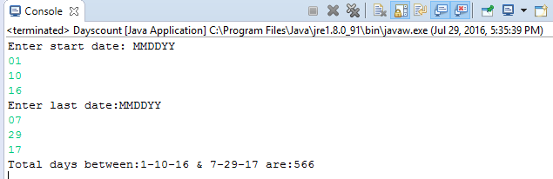

* 1. **How to divide a number by 2 without using / operator?**

**Code:**

**import** java.util.Scanner;

**public** **class** divideby2 {

**public** **static** **void** main(String[] args) {

System.***out***.println("Enter a number");

Scanner s= **new** Scanner(System.***in***);

**int** b= s.nextInt();

**int** temp=b;

**int** counter=0;

**while**(b>=2){

b=b-2;

counter++;

}

System.***out***.println("Number " +temp+ " is divided by 2 and division is = " +counter +" and reminder is: " +b);

}

}

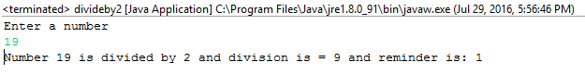

**3. How to multiply a number by 2 without using * operator?**

**Code:**

**import** java.util.Scanner;

**public** **class** MultiplyBy2 {

**public** **static** **void** main(String[] args) {

System.***out***.println("Enter a number");

Scanner s= **new** Scanner(System.***in***);

**int** b= s.nextInt();

**int** temp =b;

b=b+b;

System.***out***.println("Number " +temp+ " is multiplied by 2 and multiplication is: " +b );

}

}

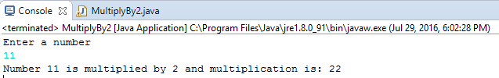

1. **How to swap two variables, by using pass by reference method?**

**Still not completely sure about reference working in swap.**

**Code 1:**

**public** **class** Swappassbyreference {

**public** **static** **void** main(String[] args) {

String abc[] = {"Java", "Reference"};

System.***out***.println("Value before Swap: " + abc[0]+" "+abc[1]);

*swapbyreference*(abc);

System.***out***.println("Value after Swap: " + abc[0]+" "+abc[1]);

}

**static** **void** swapbyreference(String[] a) {

String temp = a[0];

a[0] = a[1];

a[1] = temp;

}

}

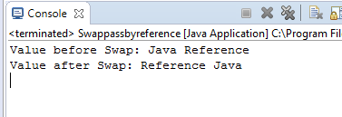

**Code 2:**

**public** **class** SwapIntegerByref {

**public** **static** **void** main(String[] args) {

**int**[] a= {1,2};

System.***out***.println("Value before Swap: " + a[0]+" "+a[1]);

*swap*(a);

System.***out***.println("Value before Swap: " + a[0]+" "+a[1]);

}

**static** **void** swap(**int** [] values){

**int** temp= values[0];

values[0]=values[1];

values[1]= temp;

}

}

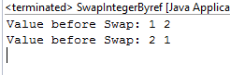

7. **Write a program to implement ArrayList and Linked list**

Code: **ArrayList**

**import** java.util.ArrayList;

**import** java.util.List;

**public** **class** ArrayListpgm {

**public** **static** **void** main(String[] args) {

List <String> aL = **new** ArrayList <String>();

aL.add("This");

aL.add("Is");

aL.add("My");

aL.add("First");

aL.add("ArrayList");

aL.add("Program");

System.***out***.println("Contents in the arrayList are: " +aL);

aL.add(6,"in");

aL.add(7,"this");

aL.add(8,"class");

aL.remove(2);

System.***out***.println("Contents in the arrayList after modification are: " +aL);

}

}

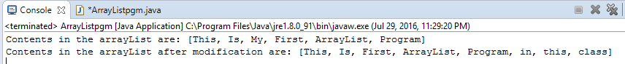

**Code: Linked list**

import java.util.LinkedList;

import java.util.List;

public class Linkedlistpgm {

public static void main(String[] args) {

List<String> linkedlist= new LinkedList <String>();

linkedlist.add("First");

linkedlist.add("Second");

linkedlist.add("Third");

linkedlist.add("Fourth");

linkedlist.add("Fifth");

System.out.println("Contents in the linkedlist are: " +linkedlist);

int a= linkedlist.size();

System.out.println("Linkedlist size is: " +a);

linkedlist.remove(1);

linkedlist.set(1, "Second added again");

System.out.println("Contents in the linkedlist after modification are: " +linkedlist);

}

}

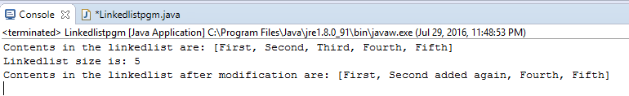8. **Write a program for Insertion Sort in java.**

**Code:**

**import** java.util.Scanner;

**public** **class** InsertionSort {

**public** **static** **void** main(String[] args) {

System.***out***.println("Enter number of array elements:");

Scanner s= **new** Scanner(System.***in***);

**int** x=s.nextInt();

**int**[] a=**new** **int**[x];

System.***out***.println("Unsorted array is:" );

**for**(**int** i=0;i<x;i++){

a[i]= s.nextInt();

}

**for**(**int** i= 1;i<a.length;i++){

**for**(**int** j=i;j>0;j--){

**if**(a[j]<a[j-1]){

**int** temp= a[j];

a[j]=a[j-1];

a[j-1]=temp;

}

}

}

System.***out***.println("");

System.***out***.println("Sorted array is:" );

**for**(**int** i=0;i<a.length;i++){

System.***out***.println(+a[i]);

}

}

}

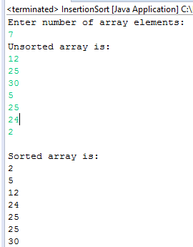

10. **Find longest substring without repeating characters**

11. **Write a program to remove duplicates from sorted array**

**Code**:

**import** java.util.Scanner;

**public** **class** DuplicatedfromSortedarray {

**public** **static** **void** main(String[] args) {

System.***out***.println("Enter number of array elements:");

Scanner s= **new** Scanner(System.***in***);

**int** x=s.nextInt();

**int**[] a=**new** **int**[x];

System.***out***.println("Unsorted array is:" );

**for**(**int** i=0;i<x;i++){

a[i]= s.nextInt();

}

**for**(**int** i= 1;i<a.length;i++){

**for**(**int** j=i;j>0;j--){

**if**(a[j]<a[j-1]){

**int** temp= a[j];

a[j]=a[j-1];

a[j-1]=temp;

}

}

}

System.***out***.println("");

System.***out***.println("Sorted array is:" );

**for**(**int** i=0;i<a.length;i++){

System.***out***.println(+a[i]);

}

System.***out***.println("Removing duplicates if any:");

**int** b = 0;

a[b] = a[0];

**for** (**int** i = 1; i < a.length; i++)

{

**if** (a[b] != a[i])

{

b++;

a[b]=a[i];

}

}

**for**(**int** i=0;i<=b;i++)

{

System.***out***.println(a[i]);

}

}

}

12. **Write a program to print fibonacci series.**

Code:

**public** **class** Fibonacci_series {

**public** **static** **void** main(String[] args) {

**int**[]a= **new** **int** []{1,1,2,3,5,8,13,21};

**int** sum,c;

**boolean** fseries=**false**;

**for**(**int** i=0;i<a.length-2;i++){

sum=0;

sum=a[i]+a[i+1];

c=a[i+2];

fseries=**false**;

**if**(sum==c){

fseries=**true**;

}

**else**{

System.***out***.println("Array does not follow Fibonacci_series");

**break**;

}

}

**if**(fseries)

{

System.***out***.println("Array follow Fibonacci_series");

}

}

}

**Output:**

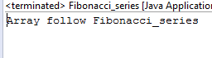

13. **Write a program to find out duplicate characters in a string**

**Code:**

**import** java.util.Scanner;

**public** **class** DuplicatecharString {

**public** **static** **void** main(String[] args) {

System.***out***.println("Enter a string:");

StringBuffer sf=**new** StringBuffer();

Scanner s= **new** Scanner(System.***in***);

sf.append(s.nextLine());

**for** (**int** i=0;i<sf.length();i++){

**int** counter=0;

**for** (**int** j=0;j<sf.length();j++){

//here is the sun

**if**((j<i) &&(sf.charAt(i))==sf.charAt(j)){

**break**;

}

**if**((sf.charAt(i))==sf.charAt(j)&&(j>i)){

counter++;

**if**((counter==1)&&(sf.charAt(i))!=32){

System.***out***.println("Duplicate character in string is: " +sf.charAt(j));

}

}

}

}

}

}

**Output:**

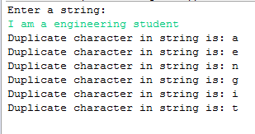

**16.Write a program to find the given number is Armstrong number or not?**

**Code:**

**import** java.util.Scanner;

**public** **class** Armstrong_Number {

**public** **static** **void** main(String[] args) {

System.***out***.println("Enter a number");

Scanner s= **new** Scanner(System.***in***);

**int** n= s.nextInt();

**int** c=0,a,temp;

temp=n;

**while**(n>0)

{

a=n%10; // value of a changes

n=n/10;

c=c+(a*a*a);

}

**if**(temp==c)

System.***out***.println("armstrong number");

**else**

System.***out***.println("Not armstrong number");

}

}

